Exercise: Chunking
I would share some the next step of RPM:
Remember we talked about the first 3 questions:
Result: The first question to ask when planning anything is, “What Result am I committed to achieve?”
Purpose: The second set of questions to ask yourself is. “What is my Purpose? Why do I want to do this? What will it give me? How will that make me feel?”
Massive Action Plan: Once you have a clear outcome (Result) and a compelling Purpose, ask yourself the third set of questions of RPM, “What specific actions do I need to take to achieve this result? What’s my Massive Action Plan?”

And put it into a real agenda and working towards the result it helps if you start chuncking it.
To succeed in anything without feeling overwhelmed, it's crucial to effectively organize a variety of tasks so they collectively contribute to a specific goal. Our minds have the remarkable ability to either dissect an experience into countless pieces or to synthesize it into a cohesive whole. For instance, attempting to tackle an entire project in one go (like trying to eat a whole whale in a single bite) can be overwhelming. On the other hand, breaking a task down into too many small steps can be just as daunting and frustrating.
Most people can only maintain focus on a few things at a time. It’s common for us to grasp things better when they are presented in groups of three. Beyond that, many of us start to feel swamped. Essentially, mastering a skill involves consolidating numerous tasks into just one or two primary areas of focus. This simplification helps prevent the feeling of being overwhelmed and enhances our efficiency.
Example for you: To do list
- Order vinyl supplies.
- Meet with graphic designer for album covers.
- Update website with new product listings.
- Schedule client meetings for custom orders.
- Visit local record stores for partnership opportunities.
- Plan social media posts for the week.
- Review and refine the business plan.
- Organize inventory in the storage room.
- Check sound equipment and arrange for maintenance.
- Arrange a photo shoot for upcoming vinyl releases.
- Have lunch with a friend to catch up.
- Call girlfriend to plan a date night.
- Meet with marketing expert to discuss launch strategies.
- Attend yoga class to unwind.
- Spend Sunday afternoon with friends.
- Book tickets for a concert with my girlfriend.
- Schedule a casual meeting at a café with fellow music enthusiasts.

Question: Do any of these actions relate to a similar Result?

- Order vinyl supplies.
- Call girlfriend to plan a date night
- Meet with graphic designer for album covers.
- Spend Sunday afternoon with friends.
- Update website with new product listings.
- Schedule client meetings for custom orders.
- Visit local record stores for partnership opportunities.
- Attend gym class to unwind.
- Plan social media posts for the week.
- Review and refine the business plan.
- Organize inventory in the storage room.
- Arrange a photo shoot for upcoming vinyl releases.
- Have lunch with a friend to catch up.
- Meet with marketing expert to discuss launch strategies.
- Book tickets for a concert with my girlfriend.
- Schedule a casual meeting at a café with fellow music enthusiasts.

The power of RPM is that a list of 12 action items can be grouped (or chunked) together into few Results.
The power of RPM is that 12 different action items can be grouped together into only a only a few Results. This one is around your business and your personal life ; looking at the original list,. You could chunk the other items into Results having to do with your business or your personal life / relationships
- Review and refine the business plan.
- Update website with new product listings.
- Meet with marketing expert to discuss launch strategies.
- Plan social media posts for the week.
- Arrange a photo shoot for upcoming vinyl releases.

- Order vinyl supplies.
- Meet with graphic designer for album covers.
- Schedule client meetings for custom orders.
- Visit local record stores for partnership opportunities.
- Organize inventory in the storage room.

- Book tickets for a concert with my girlfriend.
- Schedule a casual meeting at a café with fellow music enthusiasts.
- Call girlfriend to plan a date night
- Spend Sunday afternoon with friends.
- Attend gym class to unwind.
- Have lunch with a friend to catch up.

By doing this you see that you can create boxes in your day that you work on your business, make time for yourself, your relationships and this way you create overview and you can find out if the deadline is reasonable .
Use Chunking to Reduce Overwhelm in ANY Area of Your Life. Chunking helps you make sense out of chaos.
Like this example:
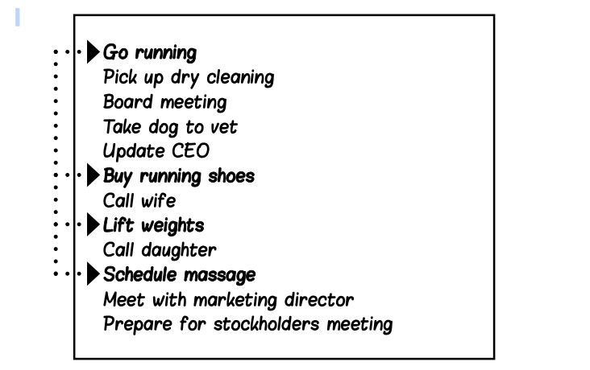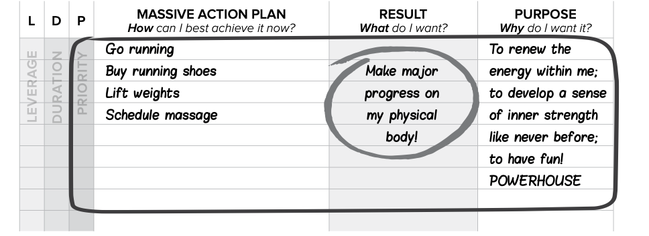
I took this from Tony Robbins, so jus to mention this is not mine. (copyrights)

I hope this is helpful for you

Cheers, Debbie

